Bezier curve

Abstract:
There are a wide range of techniques available for cooperative motion planning of autonomous vehicles. This paper focuses on some methods, known as Direct Methods, that solve motion planning expressed as a continuous- time optimal control problem. Out of all the Direct Methods that were investigated, methods based on Bernstein polynomials were shown to provide the best results, namely, trajectories that prevent inter-vehicular and environmental collisions while satisfying vehicle constraints and keeping energy of temporal- related costs close to optimal.

Introduction:
Worldwide, there has been growing interest in the execution of missions of increasing complexity involving the use of several autonomous vehicles acting cooperatively without constant supervision of human operators. A key-enabling factor for the execution of such missions is the availability of advanced methods for cooperative motion planning that take explicitly into account temporal and spatial constraints, intrinsic vehicle limitations and energy minimization requirements. Motivated by the current trends in this area of research, the motion planning technique studied here aims to find feasible and safe trajectories for a group of vehicles such that they reach several target locations at the same time (the so called ”simultaneous arrival problem”) and avoid inter- vehicle as well as vehicle/obstacle collisions, subject to the constraint that the overall energy required for vehicle motion is minimized.
Here, the motion planning problem is formulated as a continuous-time optimal control problem. Different numerical Direct Methods that approximate its solutions in a discretized setting are explored, each with its own advantages and dis- advantages, which make them best-suited for certain types of problems. Some of the Direct Methods include Single Shooting , Multiple Shooting, Monomial based polynomial methods and Bernstein Polynomial based methods. Bernstein polynomial-based bb methods were the focus of this study because these polynomials possess convenient properties that allow for efficient computation and enforcement of constraints along the vehicles’ trajectories, such as dynamics, maximum speeds, angular rates, and distances to known obstacles and other vehicles.
Different mathematical tools to calculate cost and feasibility are evaluated. Finally, the results of simulations aimed at showing the efficacy of the complete motion planning algorithm developed for specific numbers of vehicles and different constraints are presented.

BE´ZIER CURVES

A Bezier curve is a parametric curve used in computer graphics and related fields. The curve is named after Pierre Bezier, who used it in the 1960s for designing curves for the bodywork of Renault cars. Other uses include the design of computer fonts and animation. The mathematical basis for Be´zier curves, the Bernstein polynomials, was established in 1912, but the polynomials were not applied to graphics until some 50 years later when mathematician Paul de Casteljau in 1959 developed de Casteljau’s algorithm, a numerically stable method for evaluating the curves, and became the first to apply them to computer-aided design at French auto-maker Citroen.
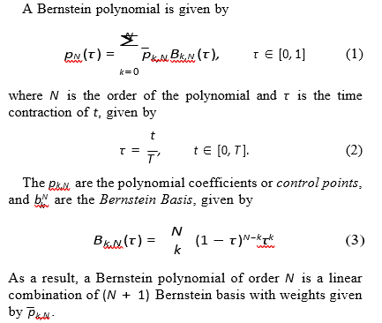

It is a parametric curve used in computer graphics and related fields.
A set of discrete "control points" defines a smooth, continuous curve by means of a formula. Usually, the curve is intended to approximate a real-world shape that otherwise has no mathematical representation or whose representation is unknown or too complicated.
Bézier curve is named after French engineer Pierre Bézier, who used it in the 1960s for designing curves for the bodywork of Renault cars. Other uses include the design of computer fonts and animation. Bézier curves can be combined to form a Bézier spline or generalized to higher dimensions to form Bézier surfaces. The Bézier triangle is a special case of the latter.
In vector graphics, Bézier curves are used to model smooth curves that can be scaled indefinitely. "Paths", as they are commonly referred to in image manipulation programs, are combinations of linked Bézier curves. Paths are not bound by the limits of rasterized images and are intuitive to modify.
Bézier curves are also used in the time domain, particularly in animation user interface design and smoothing cursor trajectory in eye gaze controlled interfaces. For example, a Bézier curve can be used to specify the velocity over time of an object such as an icon moving from A to B, rather than simply moving at a fixed number of pixels per step. When animators or interface designers talk about the "physics" or "feel" of an operation, they may be referring to the Bézier curve used to control the velocity over time of the move in question.
This also applies to robotics where the motion of a welding arm, for example, should be smooth to avoid unnecessary wear.

Invention:

The mathematical basis for Bézier curves — the Bernstein polynomials—was established in 1912, but the polynomials were not applied to graphics until some 50 years later when mathematician Paul de Casteljau in 1959 developed de Casteljau's algorithm, a numerically stable method for evaluating the curves, and became the first to apply them to computer-aided design at French automaker Citroën. Yet, de Casteljau's method was patented in France but not published until the 1980s while the Bézier polynomials were widely publicized in the 1960s by the French engineer Pierre Bézier, who discovered them independently and used them to design automobile bodies at Renault.

- General definition:
Bézier curves can be defined for any degree n.

- Recursive definition:
A recursive definition for the Bézier curve of degree n expresses it as a point-to-point linear combination (linear interpolation) of a pair of corresponding points in two Bézier curves of degree n − 1.
This recursion is elucidated in the animations below.

- Explicit definition:
The formula can be expressed explicitly as follows (where t0 and (1-t)0 is extended continuously to be 1 throughout [0,1]):

Properties:

A cubic Bézier curve (yellow) can be made identical to a quadratic one (black) by
1. copying the end points, and
2. placing its 2 middle control points (yellow circles) 2/3 along line segments from the end points to the quadratic curve's middle control point (black rectangle).
The curve begins at P0 and ends at Pn; this is the so-called endpoint interpolation property.
The curve is a straight line if and only if all the control points are collinear.
The start and end of the curve is tangent to the first and last section of the Bézier polygon, respectively.
A curve can be split at any point into two sub curves, or into arbitrarily many sub curves, each of which is also a Bézier curve.

Offsets (or stroking) of Bézier curves
The curve at a fixed offset from a given Bézier curve, called an offset or parallel curve in mathematics (lying "parallel" to the original curve, like the offset between rails in a railroad track), cannot be exactly formed by a Bézier curve (except in some trivial cases). In general, the two-sided offset curve of a cubic Bézier is a 10th-order algebraic curve[14] and more generally for a Bézier of degree n the two-sided offset curve is an algebraic curve of degree 4n−2. However, there are heuristic methods that usually give an adequate approximation for practical purposes.

In the field of vector graphics, painting two symmetrically distanced offset curves is called stroking (the Bézier curve or in general a path of several Bézier segments). The conversion from offset curves to filled Bézier contours is of practical importance in converting fonts defined in Metafont, which require stroking of Bézier curves, to the more widely used PostScript type 1 fonts, which only require (for efficiency purposes) the mathematically simpler operation of filling a contour defined by (non-self-intersecting) Bézier curves.

Degree elevation
A Bézier curve of degree n can be converted into a Bézier curve of degree n + 1 with the same shape. This is useful if software supports Bézier curves only of specific degree. For example, systems that can only work with cubic Bézier curves can implicitly work with quadratic curves by using their equivalent cubic representation.

Applications:

- Computer graphics

Bézier path in Adobe Illustrator [We will be applying the concepts of Bezier path]
Bézier curves are widely used in computer graphics to model smooth curves. As the curve is completely contained in the convex hull of its control points, the points can be graphically displayed and used to manipulate the curve intuitively. Affine transformations such as translation and rotation can be applied on the curve by applying the respective transform on the control points of the curve.

Quadratic and cubic Bézier curves are most common. Higher degree curves are more computationally expensive to evaluate. When more complex shapes are needed, low order Bézier curves are patched together, producing a composite Bézier curve. A composite Bézier curve is commonly referred to as a "path" in vector graphics languages (like PostScript), vector graphics standards (like SVG) and vector graphics programs (like Artline, Timeworks Publisher, Adobe Illustrator, CorelDraw, Inkscape, and Allegro). To join Bézier curves into a composite Bézier curve without kinks, a property called G1 continuous, it suffices to force the control point at which two constituent Bézier curves meet to lie on the line defined by the two control points on either side.

Abstract composition of cubic Bézier curves ray-traced in 3D. Ray intersection with swept volumes along curves is calculated with Phantom Ray-Hair Intersector algorithm.
The simplest method for scan converting (rasterizing) a Bézier curve is to evaluate it at many closely spaced points and scan convert the approximating sequence of line segments. However, this does not guarantee that the rasterized output looks sufficiently smooth, because the points may be spaced too far apart. Conversely it may generate too many points in areas where the curve is close to linear. A common adaptive method is recursive subdivision, in which a curve's control points are checked to see if the curve approximates a straight line to within a small tolerance. If not, the curve is subdivided parametrically into two segments, 0 ≤ t ≤ 0.5 and 0.5 ≤ t ≤ 1, and the same procedure is applied recursively to each half. There are also forward differencing methods, but great care must be taken to analyze error propagation.
Analytical methods where a Bézier is intersected with each scan line involve finding roots of cubic polynomials (for cubic Béziers) and dealing with multiple roots, so they are not often used in practice.

The rasterization algorithm used in Meta font is based on discretizing the curve, so that it is approximated by a sequence of "rook moves" that are purely vertical or purely horizontal, along the pixel boundaries. To that end, the plane is first split into eight 45°, then the curve is decomposed into smaller segments such that the direction of a curve segment stays within one sector; since the curve velocity is a second-degree polynomial, finding the values where it is parallel to one of these lines can be done by solving quadratic equations. Within each segment, either horizontal or vertical movement dominates, and the total number of steps in either direction can be read off from the endpoint coordinates; in for example the 0–45° sector horizontal movement to the right dominates, so it only remains to decide between which steps to the right the curve should make a step up

There is also a modified curve form of Bradenham’s line drawing algorithm by Zingl that performs this rasterization by subdividing the curve into rational pieces and calculating the error at each pixel location such that it either travels at a 45° angle or straight depending on compounding error as it iterates through the curve. This reduces the next step calculation to a series of integer additions and subtractions.

Animation

In animation applications, such as Adobe Flash and Synfig, Bézier curves are used to outline, for example, movement. Users outline the wanted path in Bézier curves, and the application creates the needed frames for the object to move along the path.

In 3D animation, Bézier curves are often used to define 3D paths as well as 2D curves for keyframe interpolation. Bézier curves are now very frequently used to control the animation easing in CSS, JavaScript, Java and Flutter SDK.

Fonts

TrueType fonts use composite Bézier curves composed of quadratic Bézier curves. Other languages and imaging tools (such as PostScript, Asymptote, Meta font, and SVG) use composite Béziers composed of cubic Bézier curves for drawing curved shapes. OpenType fonts can use either kind of curve, depending on which font technology underlies the OpenType wrapper.

The internal rendering of all Bézier curves in font or vector graphics renderers will split them recursively up to the point where the curve is flat enough to be drawn as a series of linear or circular segments. The exact splitting algorithm is implementation dependent, only the flatness criteria must be respected to reach the necessary precision and to avoid non-monotonic local changes of curvature. The "smooth curve" feature of charts in Microsoft Excel also uses this algorithm.

Because arcs of circles and ellipses cannot be exactly represented by Bézier curves, they are first approximated by Bézier curves, which are in turn approximated by arcs of circles. This is inefficient as there exists also approximations of all Bézier curves using arcs of circles or ellipses, which can be rendered incrementally with arbitrary precision. Another approach, used by modern hardware graphics adapters with accelerated geometry, can convert exactly all Bézier and conic curves (or surfaces) into NURBS, that can be rendered incrementally without first splitting the curve recursively to reach the necessary flatness condition. This approach also preserves the curve definition under all linear or perspective 2D and 3D transforms and projections.

Font engines, like FreeType, draw the font's curves (and lines) on a pixelated surface using a process known as font rasterization.

Robotics

Bézier curves can be used in robotics to produce trajectories of an end-effector due to the virtue of the control polygon’s ability to give a clear indication of whether the path is colliding with any nearby obstacle or object. Furthermore, joint space trajectories can be accurately differentiated using Bézier curves. Consequently, the derivatives of joint space trajectories are used in the calculation of the dynamics and control effort (torque profiles) of the robotic manipulator.

Using Bezier Path for defining Airplane Trajectories

The Use of Beezier Curves for Optimal Motion Planning of Autonomous Vehicles

COOPERATIVE MOTION PLANNING: PROBLEM FORMULATION AND ADOPTED SOLUTIONS
In this section, implementation of a Direct Method based on the use of Bernstein polynomials is described. This section focuses on formalizing the optimization problem for multiple minimize solutions for particular optimization problems are presented based on the formulations.
Optimisation Problem
The Motion Planning problem for multiple vehicles that are the focus of this project consists of a ”go-to” formation maneuver . It consists of the simultaneous arrival of a formation of vehicles to desired locations whilst simultaneously avoiding collisions between each other and the environment.
The optimal control formulation for this motion planning problem is given by
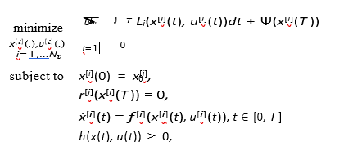

where [i] denotes the i-th vehicle, x(t) is defined as x : [0, T ] Rnx , u(t) is defined as u : [0, T ] Rnu , f (x, t) is the system of equations for the dynamics, defined as f : Rnx Rnu Rnx , x0 is the initial state, h(x(t), u(t)) represents the path constraints, r(x(T )) = 0 the termi- nal constraints, L(x(t), u(t)) is the running cost, defined as
L : Rnx × Rnu → R, Ψ(x(t)) is the terminal cost defined as
Ψ : Rnx → R and finally T is known as the time ”horizon”,
i.e., no matter what motion planning algorithm is used, the produced control law will only be valid within time t ∈ [0; T ].

A direct method based on Bernstein polynomials is used here. This means that some or all of the state variables/inputs are approximated by polynomials, each with the same order N . By using these polynomials all of the states and inputs for each vehicle combined will produce a total of (Nv (nu + nx) (N + 1)) control points.
Let t0, t1, ..., tN be a set of equidistant time nodes such that
tj = j tN , with T > 0. By following the notation of Bernstein polynomials : -
: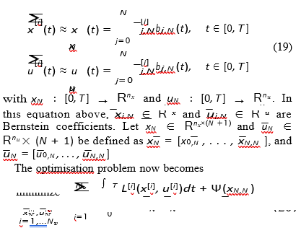
- No obstacles
The first problem considered here is for both a single Dubins’ Car and a single Medusa vehicle with no obstacles. Figure 4 show solutions for order 20 and a time horizon of 60 s. The top two plots minimize the square of the surge of the Dubins’ Car and Medusa vehicle, while the bottom two minimize the thrust τ_{u} and torque τ_{r}, respectively. This figure, and all other figures, flip x and y axis which is standard for marine vehicles.
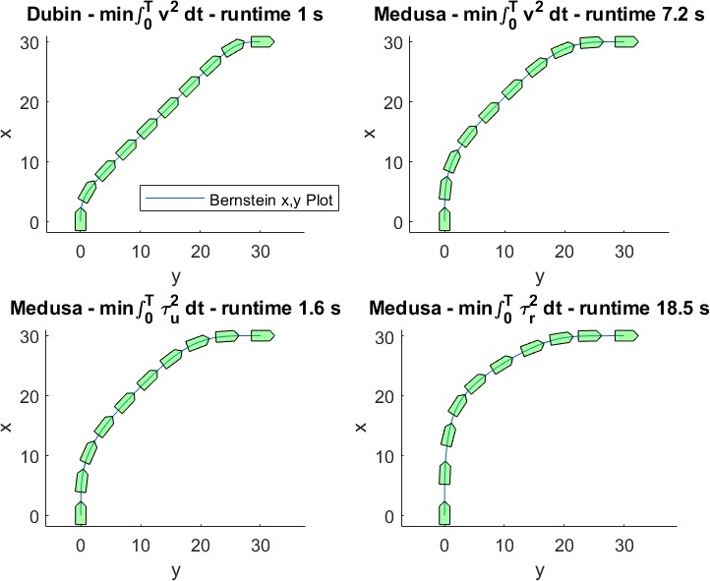
Fig. 4: Solutions of order N = 20 without obstacles and final time
T = 60

B. Obstacles
The top left solution of figure 4 serves as the baseline for comparison without obstacles. Specifically, the solutions presented in this section use the same velocity minimization T 20
and the same order of polynomial N = 20 as the Dubins’
Car. The only difference is the presence of the different obstacles. Figure 5 show the solutions of the performed tests. The titles of the plots which say ”Constrained” refer to when the environmental obstacle is implemented as an optimization constraint. The titles which say ”Unconstrained” refer to plots resulting from unconstrained optimization, i.e., the environ- mental constraint was moved to the cost via the Log Barrier Functional. The gap that we see between the curve and the obstacle is the result of balancing the running cost and the Log Barrier component. The running cost ”pushes” the trajectory to the shortest path while the log barrier component ”pushes” the trajectory ”away” from the obstacle. One implication is that running cost can never be ideal because the vehicle had to travel an extra amount of distance. Using the Log Barrier function, however, has the advantage of potentially reducing the runtime of the optimization process, as can be seen by comparing the computation times of the problems with the polygon obstacles. Furthermore, the large difference in computation time between polygon obstacles and circle obstacles can be explained by the fact that the Minimum Distance to Polygon algorithm is iterative, which means that all of the duration of the individual runs quickly add up.
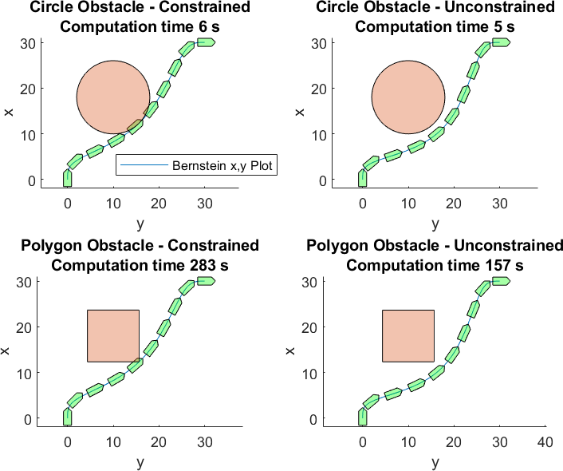
Solution of order N = 20 with obstacles and final time T = 60

C. Multiple Vehicles
To illustrate the use of multiple vehicles, a series of runs are presented in figure 6. These solutions are run with the inter vehicular constraints implemented as constraints on the optimization problem, as opposed to imposing them in the cost via the Log Barrier Functional. Specifically, the imposed constraint is a separation of 3 m between trajectories calculated with the sampling-based algorithm. Given that the problem focuses on trajectories, there is no problem in seeing the paths intersect. The same two vehicle problem with order N = 10 takes a total of 56 s with the iterative Bernstein to a point algorithm which again shows how using an iterative algorithm with an optimization problem adds a lot of computation time.

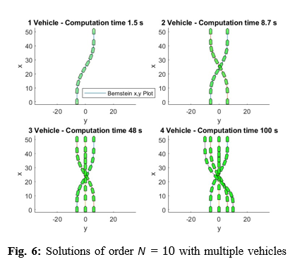

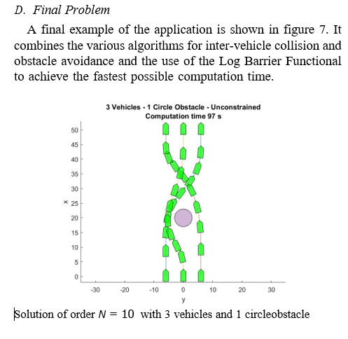
VI. CONCLUSIONS
This project consisted in the development a fast optimal motion planning algorithm for finding feasible and safe trajectories for a group of vehicles such that they reach a number of target points at the same time. It involved solving an optimal control problem by finding its equivalent finite dimensional optimization problem. Bezier curves were chosen to approximate the optimal trajectory due to their convenient properties that allow efficient computation and enforcement of constraints along the vehicles’ trajectories.
The motion planning algorithm was tested with two Autonomous Marine Vehicle (AMV) models: the Dubins’ car model and the Medusa model, whose ruling kinematic and dynamics equations were also studied and presented here. It can be concluded that motion planning can now be performed for non-differentially flat systems such as the Medusa model. The motion planning algorithm not only solves the problem for the go-to-formation maneuver but also supports other kinds of missions such as those based on active navigation. There- fore, future research can be based on applying the algorithms presented here for a wide range of complex motion planning problems. Another further investigation that can be derived from this work is testing the motion planning algorithms in close cooperation with trajectory tracking such that they can be applied in real time.

Highway geometric design using Bézier curve approximation

- Abstract:

Traditional highway design procedure is a trial and error process where the system manager spends a lot of time. To improve this manual process, a new method to design highways is investigated. A mathematical function called Bézier Curve is used. Highway designs have been made with both traditional and Bézier Curve methods on a level type terrain. According to results, Bézier Curve gives a shorter highway than the traditional method. And, the curve radius is also larger than traditional method which helps improve highway safety and drivers' comfort. So, the highway designed with Bézier Curve reduces overall roadway length and larger curve radius than traditionally designed highway.

- Introduction:

Nowadays, vehicle speed increases the transportation requirements. Although increased speed is a desired feature because the value of time is further increasing, high speeds raise safety problems. Drivers are adapting themselves to the geometric design of the highway in a short time. To do that, they use the experience in previous travels where the highway characteristics are close to each other. Considering this information, it is necessary to design a highway where it is easy to get adapted and able to drive safer at high speeds. To meet this expectation, geometric standards should be examined in detail by design process. One of the major accident occurrence reason can be the lack of geometric design consistency which causes critical driving maneuvers. Also, a consistent highway design provides consecutive highway elements which produce a highway without any surprising areas. Traditionally designed highways have straight parts which are followed with some curves with different radius. In most cases, drivers drive directly from the straight parts to these curves.This problem could be eliminated using smooth and continuous curvature on design step where all the drivers get informed about the next geometric part of the highway, and how it looks. Because driving on a continuous curve, they will adapt themselves to the curves more easily.

- Bézier Curves:

Before the 1950’s, smooth shape design was very difficult. In 1959, two men who called Paul de Faget de Casteljau and Pierre Bézier, working both on two different automobile companies, worked on smoothing the intersection by iterating affine combinations of polygons. Both versions produce the same curve but because Pierre Bézier was the first to write a public paper, so the curve is called Bézier Curves.

A BC is formed in line with the control points (𝑃0 , 𝑃1 , 𝑃2 , … , 𝑃𝑛). The curve passes through first and last control points while approximating the remaining control points. However, Arikoglu and Yucesan, have studied about the minimization of the jerk energy, which means that the approximated curve could be redrawn to offset the highway from the surrounding utilities or connecting to existing networks, junctions, bridges, etc. if needed with a few calculations of new control point(s). To draw the BC, it is needed to draw a weighting function which demonstrates the influence of the control points. Hereby, Bernstein polynomials are used as weighting function and the definition is:

Bi,n(u)= n! i!(n-i)! u i (1-u) n-i (2) where P is the control point, and n is the degree of the curve.
Bernstein polynomials are the basis function of the BC. The most useful degree is 3. When n3, the curve becomes hard to work. The polynomials are symmetric and sum to unity . It is important that the basis functions always sum to unity. And, a BC of degree n is defined as follows:

C(u)= ∑ PiBi,n(u) n i=0 , u∈[0,1]

Figure 1 is an example of a BC of degree 3 with 4 control points. The straight lines between control points are called control polygons.
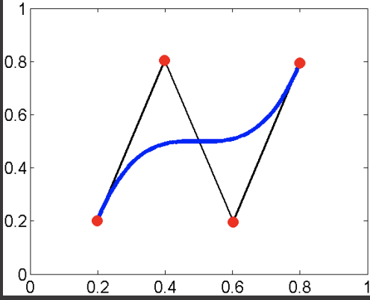

Figure 1. BC of degree 3 and control polygon saw on coordinate system As seen in Figure 1 BC starts with the first control point and ends with last control point. And, the BC is drawn with the intermediate control points. The increase in the control point’s number brings the BC closer to control polygon. To demonstrate the approach, let 𝐴 is a control polygon which has control points 𝑃(𝑥𝑖 , 𝑦𝑖). Including 𝐴 ⊂ ℝ 2 and 𝑥, 𝑦 ∈ [0,1], the control polygon is defined as follows:
A= {(x,y) | (0,y) if x=0 (x,1) if x≠0}

Now 5 control points and 15 control points on control polygon 𝐴 are selected. Figure 2 shows the difference between 5 and 15 control points

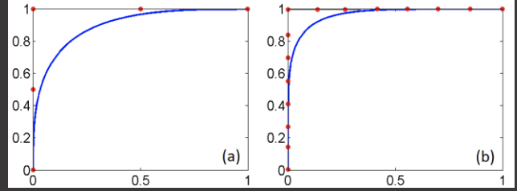

Figure 2. Difference between BC seen on coordinate system with 5 control points (a) and 15 control points (b) From Figure 2 as long as the number of control points increases on the same control polygon, the BC gets closer to the control polygon.

- Comparison of the Traditional Design with Bézier Curve:

Highways are three-dimensional objects. Although horizontal and vertical alignment is thought separately from one another, there is a relationship between the two alignments. The coordination of the horizontal and vertical alignment is important for aesthetic, economic and safe driving. So horizontal and vertical alignments should be designed together. By design process, the designer should avoid both designing a highway with steep grades to obtain minimal curvature and designing a highway with massive horizontal curvature to obtain a level vertical alignment.

- Bézier curve design:

The same highway is designed with BC. As explained in Section 2, Bézier Curves (BC) need control points to be drawn. To design the highway, the drawn null polyline is used as control polygon. Therefore, the breaking points which are occurred by merging the compasses clearances are defined as control points. So, 48 control points are obtained. Then with the help of this control points, a BC is drawn. The procedure for obtaining the final highway plan using BC approximation is described as follows:

1.Select the max grade according to terrain type and design speed.

2.Calculate the compasses clearance using Equation CC= ∆h g.

3.Draw the null polyline with the compasses clearance.

4.Determine the merging points of the compasses clearance as “Control Points”.

5.Represent the control points on a coordinate system.

6.Draw straights between the control points 𝑃0𝑃𝑖 on coordinate system and obtain “Control Polygon” .

7.Draw a new control polygon between the control point (𝑃0) and a previous drawn control polygons control point (𝑃𝑖−1).

8.Repeat Step 7 until control polygon which is a straight line between the control points 𝑃0𝑃1 is drawn on the same coordinate system and obtained (𝑖 −1) overlapping control polygons.

9.Move all the control polygons over a previously drawn control polygon by moving all the control points 𝑃𝑖 from moving control polygons to the control points 𝑃𝑖+1 from moved control polygon on the same coordinate system.

The drawn BC with 48 control points is shown in Figure 5. Drawn BC with the help of null polyline shown in Figure 5 consists of only one smooth curve without any straight alignments. However, there is almost no curvature on the transition areas between reverse curves. So, the safety criteria are provided. When the curve is needed to define in transition section and circular curve form then the BC consists of 7 transition sections and 4 circular curves from point A to B with radius 750, 350, 450, 650 m, respectively.

.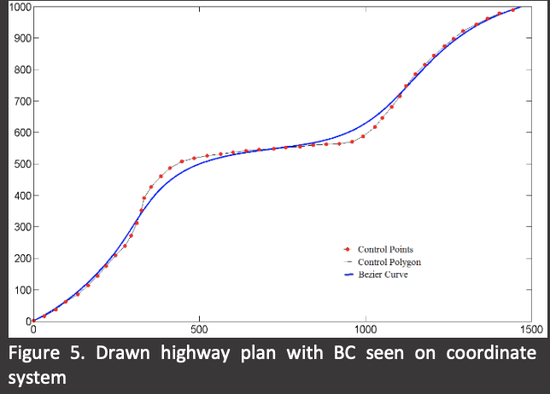

- Conclusion:

In this application traditional highway design is compared to highway design by using a mathematical curve type called BC. Therefore, a horizontal alignment is designed with traditional methods. Then the same highway is designed using BC. The results can be listed as; Traditional highway design method is a trial and error process. So, the result is more subjective than objective. Whereas, BC is a mathematical function and offers one result after determining the null polyline. For this reason, BC can be a faster solution. Highway designed with BC is in accordance with a null polyline. So, horizontal alignment is drawn accordance with vertical alignment. And, designed horizontal alignment is very smooth where the driver can drive fast and safe. Also being so smooth reduces the risk of encountering a surprising highway section. Total highway length is decreased with BC against traditional highway design while remaining faithful to the specification limit values and considering of the construction costs. By decreasing the total length of the highway, the curve radius is obtained up to 150% larger on BC method. The increase of radius decreases the centrifugal force which increases safety and the lateral jerk is decreased up to 96% which increases the comfort of the drivers and passengers. This study was only a case study and should be tested on rolling and mountainous terrain types. And, BC can also be used on vertical alignment where it seems useful as well.

EX:

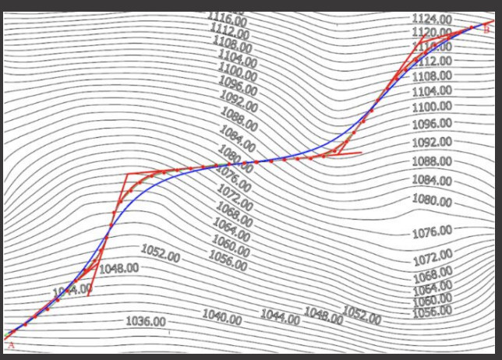

Comparision between traditional highways and highways constructed using Bezier Curves.

